Active AGV error Query
- Log into the WCS primary server
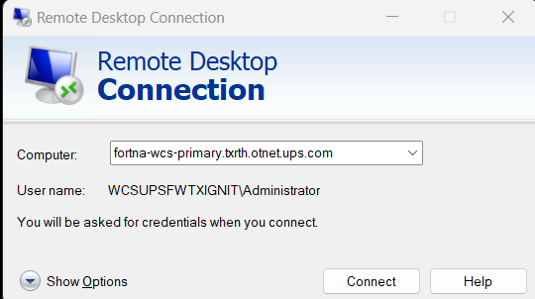
- Open the WCS database
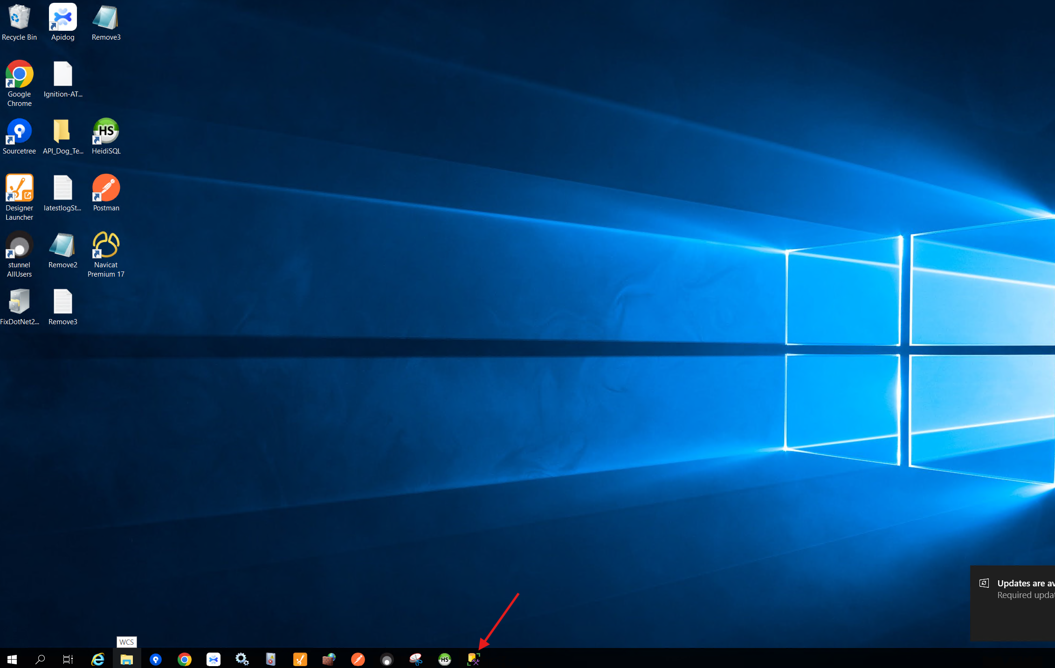

- Open a new query tab by clicking here
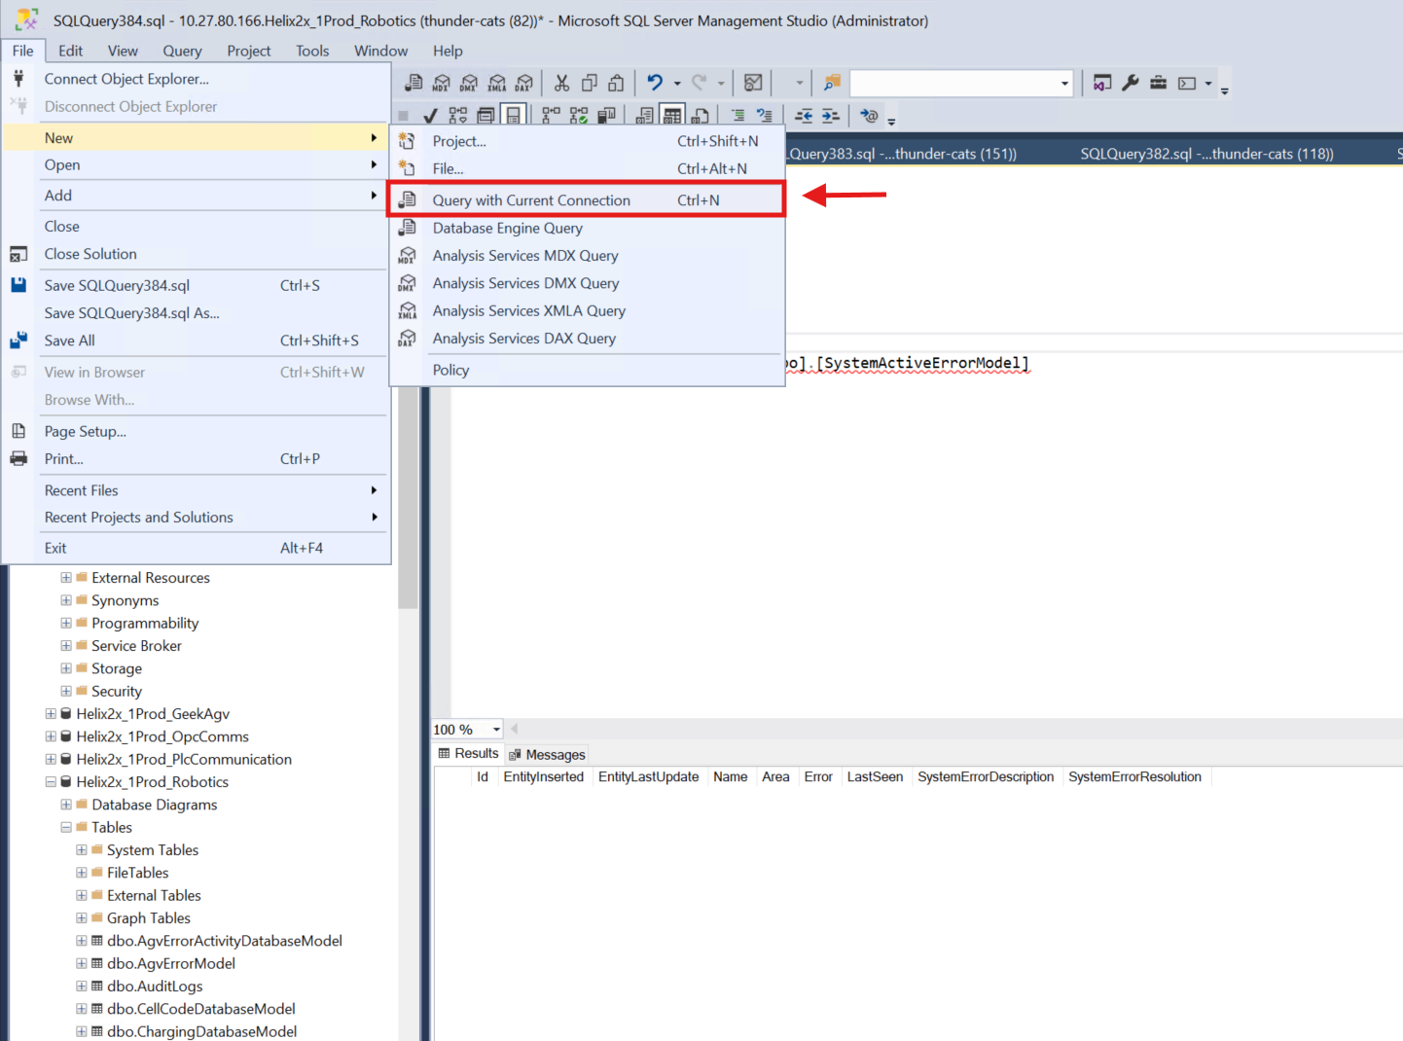
- Copy the following query and paste it in the newly opened tab:
SELECT TOP (1000) [Id]
,[EntityInserted]
,[EntityLastUpdate]
,[Name]
,[Area]
,[Error]
,[LastSeen]
,[SystemErrorDescription]
,[SystemErrorResolution]
FROM [Helix2x_1Prod_Robotics].[dbo].[SystemActiveErrorModel]
- Right click on the query and click execute
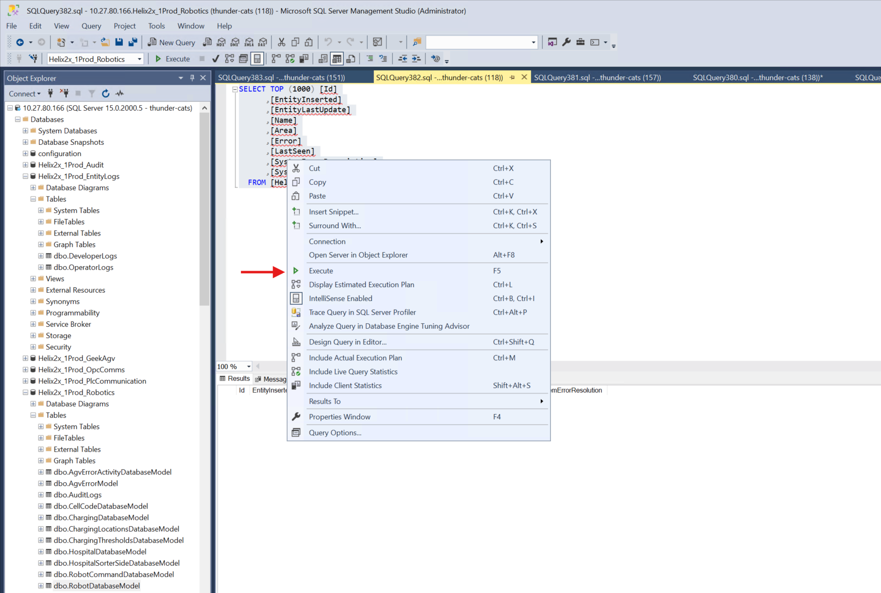
- The active errors will show up here


